45002 Variable engineering set
This set contains: 95 parts, more than 25 different shapes and colors of blocks, including connectors, screw blocks, cockpits, bottom plates, rotatable plates, windshields, buckets, shovels, propellers, mechanical arms, tracks, tires, hooks, exhaust pipes, screwdrivers and other parts of different shapes and functions. All the works and materials can be repeatedly disassembled and reassembled, easy to put together, and firmly combined. Is a set of super assembly function of varied engineering teaching AIDS, through the construction process of a variety of engineering transport tools to learn, reasonable structure construction, understanding of engineering assembly, learning safety awareness, hands-on operation, role play, let children in learning to give full play to imagination and innovative construction methods, hands-on implementation. Suitable for preschool 4-5 years old (kindergarten class) children a set of easy intellectual experience teaching AIDS.

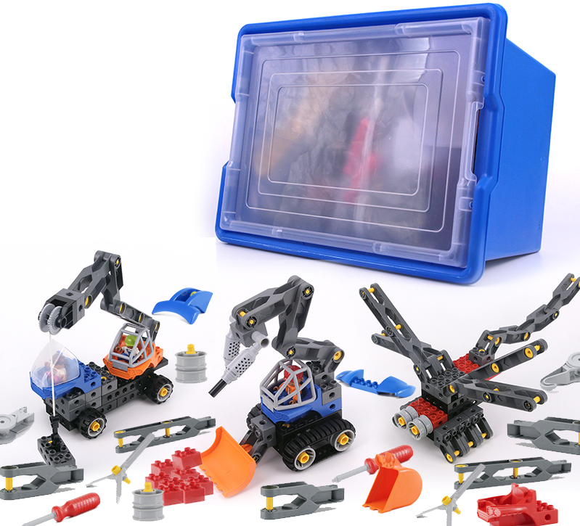

1. product information
model | 0603
material | Environmental protection ABS, etc.
packaged form | carton
package size | 44cm*32.5cm*27.5cm
weight | 3kg
number of parts | 95pcs
applicable age | 4+
Number of courses | 24+

2. Product display
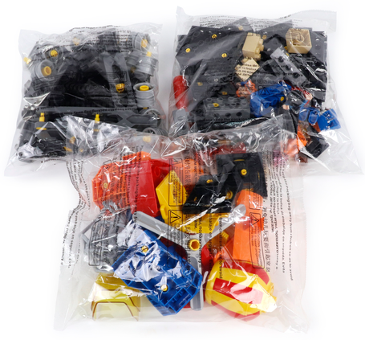

3. Supporting Information
①Online platform teaching,②Electronic building atlas.
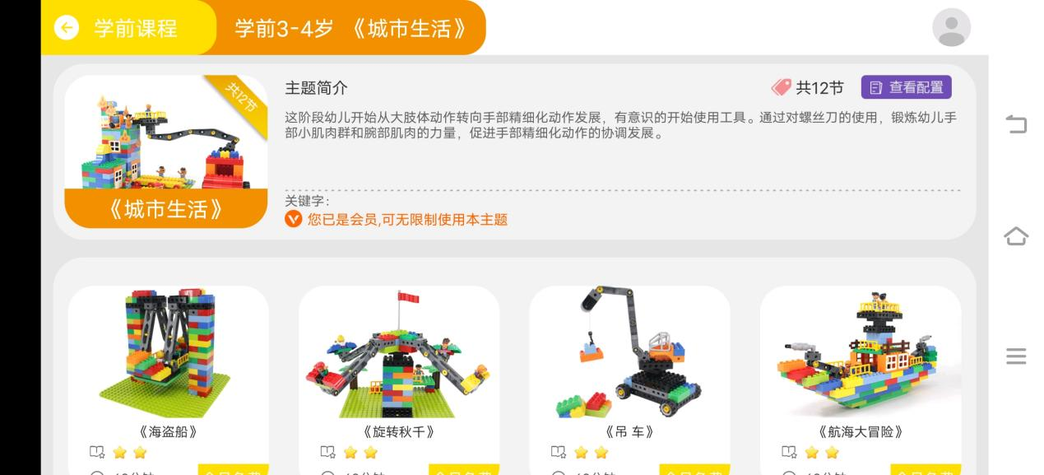

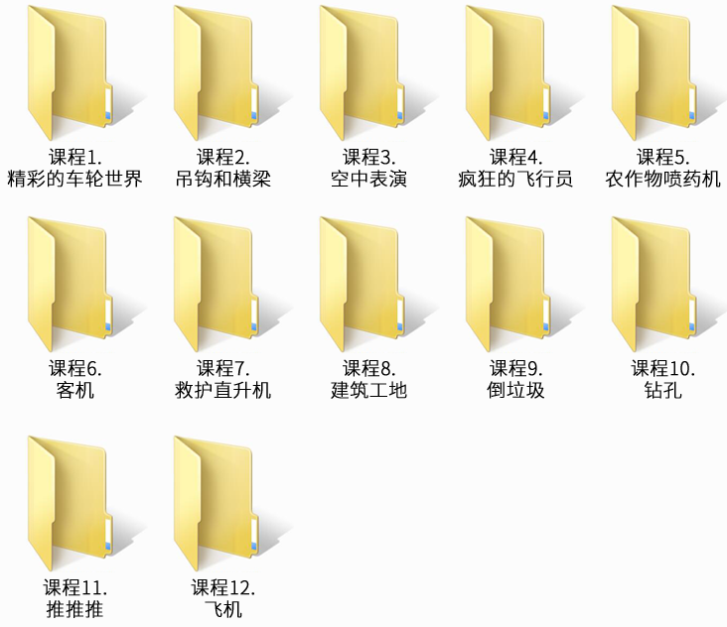

4. Presentation of modeling
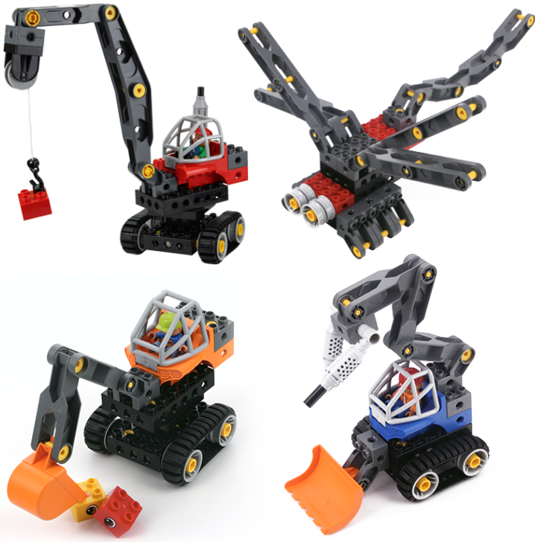
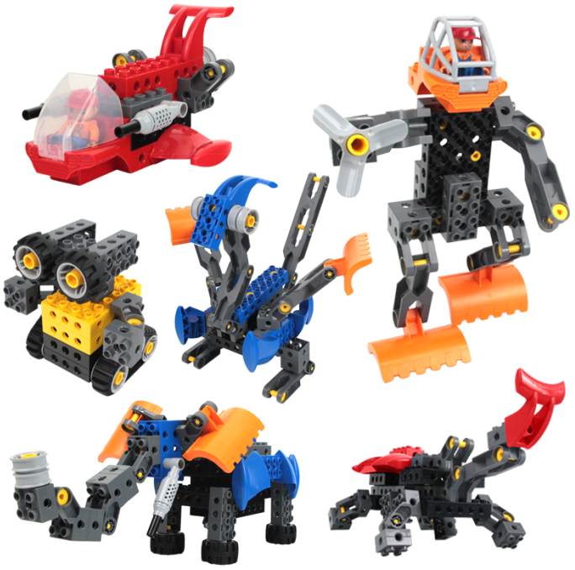
5. product list

