9076 Fun plumbing set
This set contains: 147 parts, more than 16 different shapes and colors of building blocks, such as pipe connectors, door frames, doors, flagpoles, flags, figures, balls, straight pipes, bent pipes, rockers, building blocks with eyes. All the works and materials can be repeatedly disassembled and reassembled, easy to put together, and firmly combined. It can build countless different and interesting shapes, and bring children a wonderful and interesting play-based learning atmosphere through different shapes and the mystery of small ball movement. The parts are convenient to install and have endless changes. It is a set of relaxed intellectual experience teaching AIDS suitable for preschool children aged 3-4 (kindergarten classes).
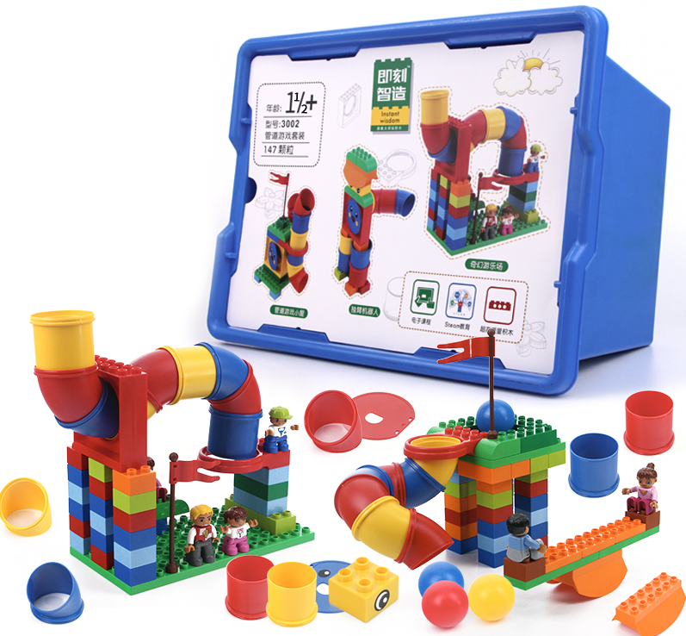
1. Product Information
model | 0602
material | Environmental protection ABS, etc.
packaged form | carton
package size | 44cm*32.5cm*27.5cm
weight | 3kg
number of parts | 147pcs
applicable age | 3+
Number of courses | 24+

- Product display
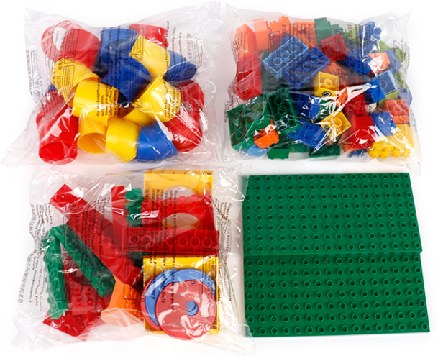
3. Supporting Information
①Online platform teaching,②Electronic building atlas.
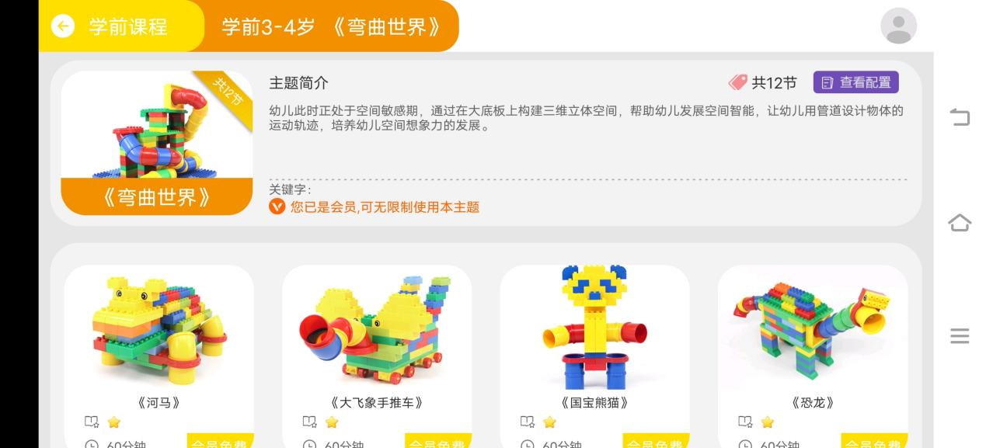
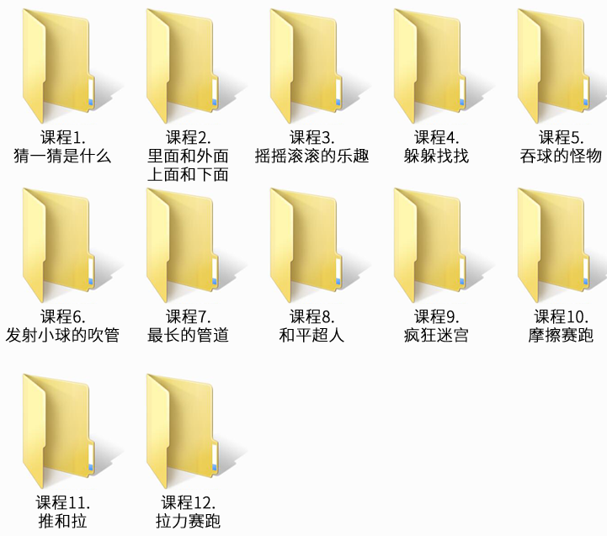

4. Presentation of modeling
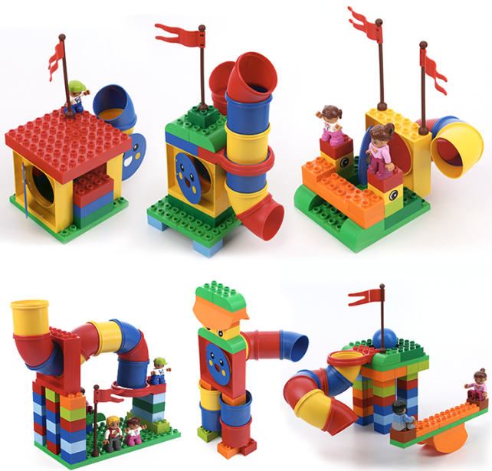
- product list
