9090 Life and Structure Suite
The set contains 54 types of particles, a total number of 440, including a large number of basic structures, can be used for tower, table, house, wall, bridge and other shapes, including doors and Windows, balustrades, trees, flowers, bridge brick, duck mouth brick, semicircular brick, etc., to meet the children's construction and fun, play freely. It is suitable for the procurement of children's projects, and the use of other sets to achieve more modeling.
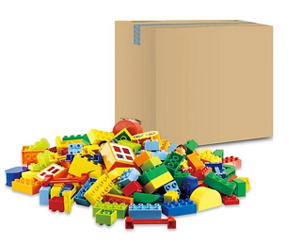
1. product information
model | 0601
material | Environmental protection ABS, etc.
packaged form | carton
package size | 40cm*40cm*25cm
weight | 5.2kg
number of parts | 440pcs
applicable age | 3+
Number of courses | 24+

2. Supporting Information
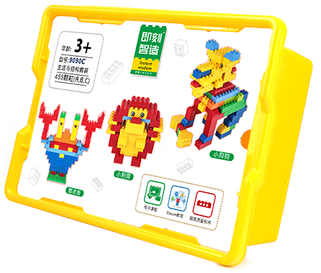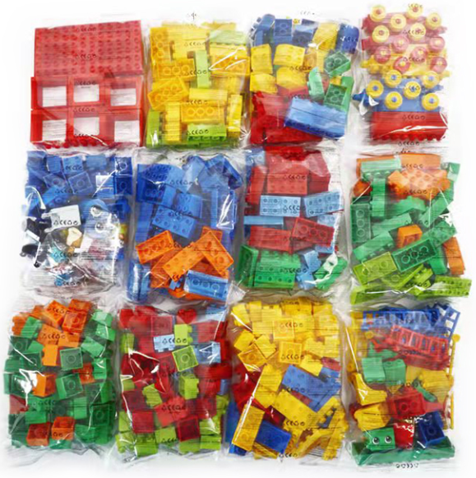
- Supporting Information
①Online platform teaching,②Electronic building atlas.
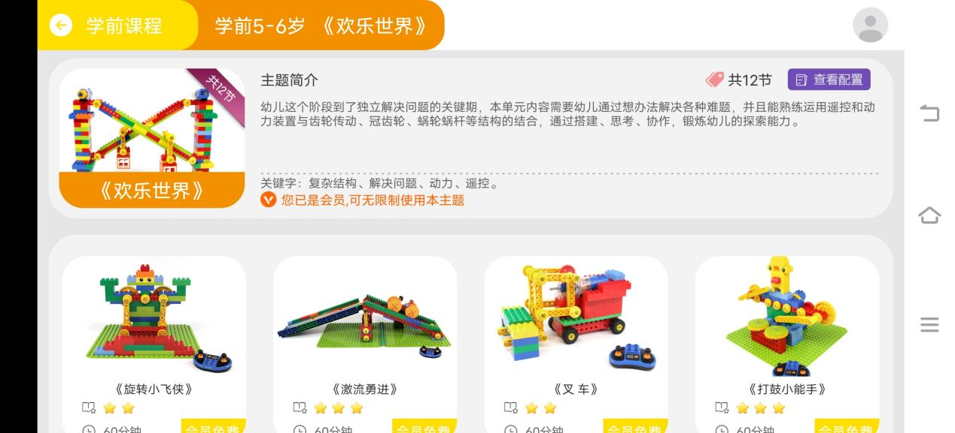

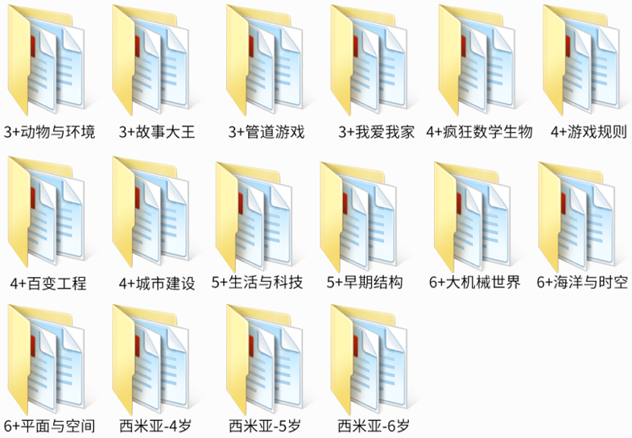

- Presentation of modeling
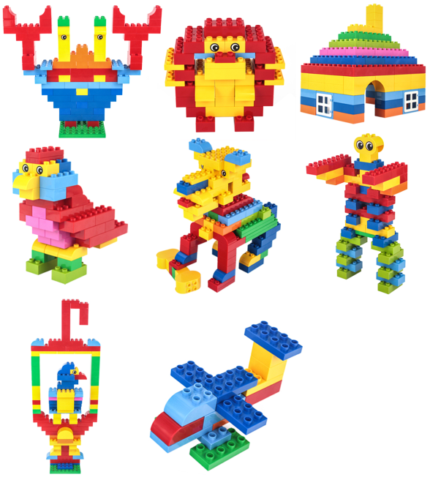
- product list
