9656 Gear machinery set
This set contains: 102 parts, more than 16 different shapes and colors of blocks, such as: lever, gear, crank, beam, turbine, turbo box, belt, hub, tire, baby face, soft board and other blocks. All the works and materials can be repeatedly disassembled and reassembled, easy to put together, and firmly combined. More than 20 kinds of mechanical devices can be freely combined to meet children's learning and realization of gear movement and simple mechanical principles. It is a functional teaching aid for hands-on construction, understanding of structure, interesting innovation and scientific exploration. Suitable for preschool 5-6 years old children (kindergarten class).

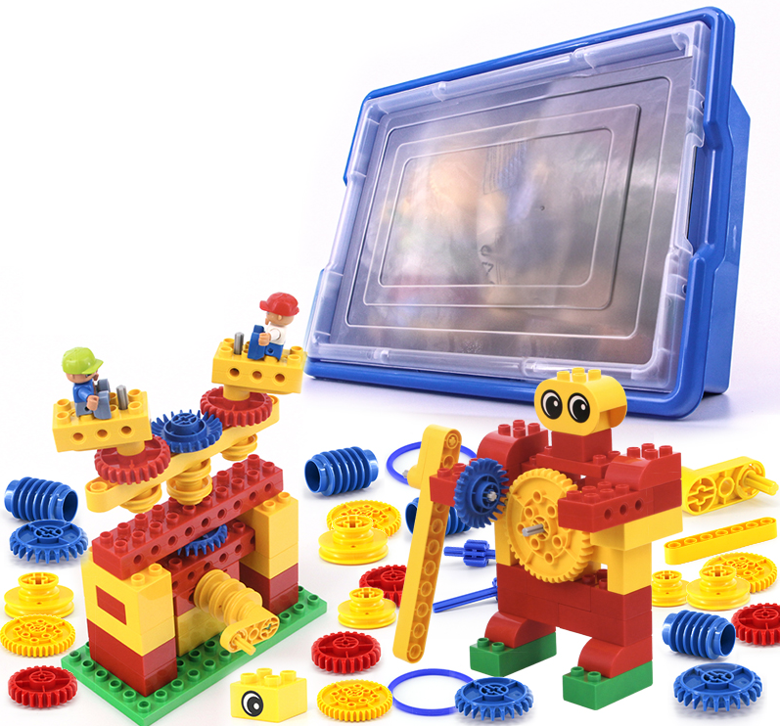
1. product information
model | 0604
material | Environmental protection ABS, etc.
packaged form | carton
package size | 44cm*32.5cm*17.5cm
weight | 3kg
number of parts | 102pcs
applicable age | 5+
Number of courses | 24+

2. Product display
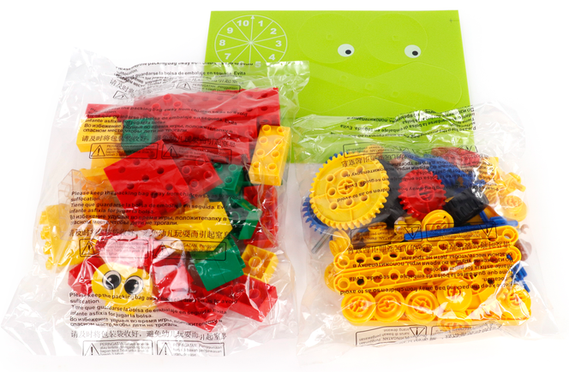

3. Supporting Information
①Online platform teaching,②Electronic building atlas.
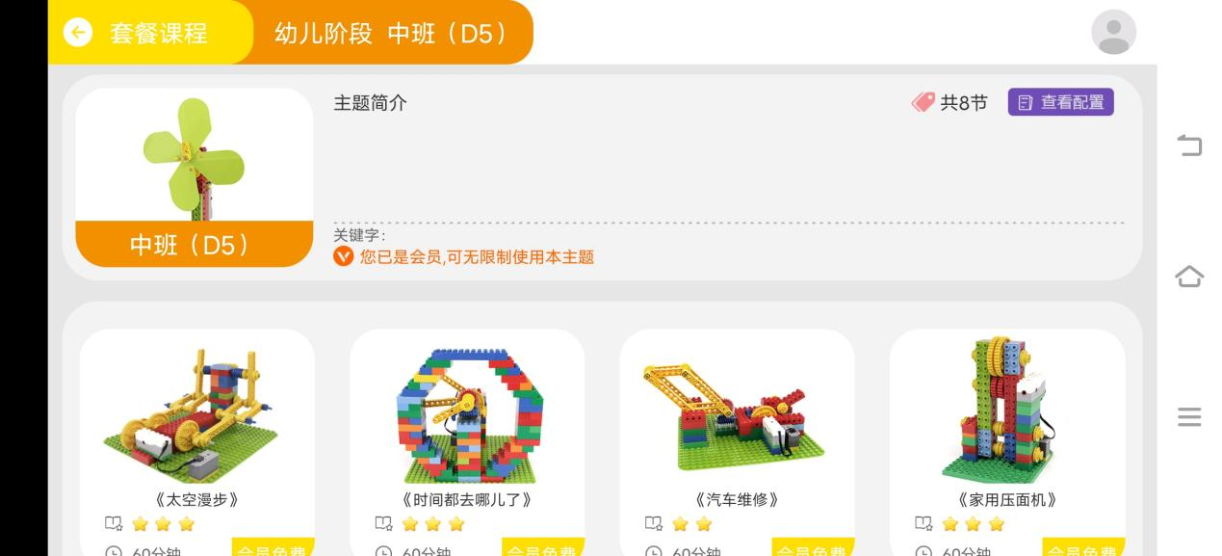
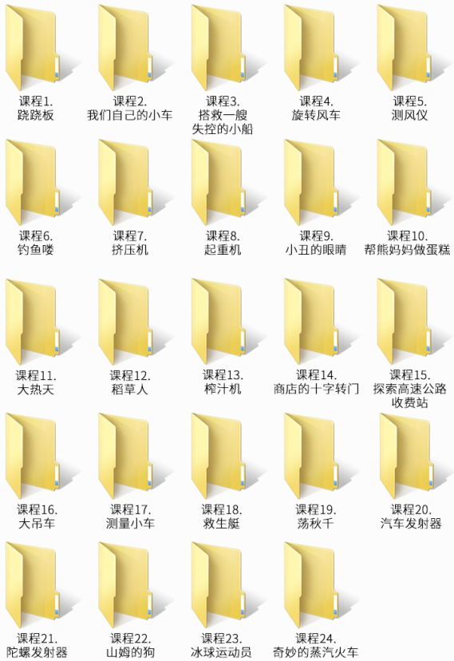
4. Presentation of modeling
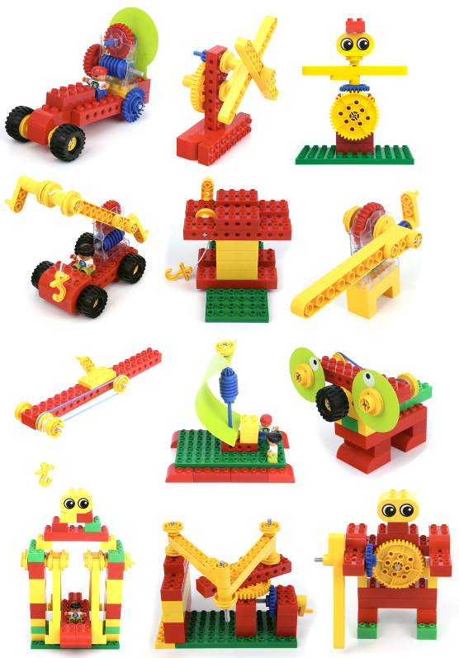

5. product list
