9686 Scientific power machinery

This set contains: 396 parts. Students can predict, observe, adjust and record various indicators through the model, and directly experience the knowledge of force, energy and magnetism. Used in conjunction with the Science and Technology Activity Pack, it provides students with more than 30 science and technology courses, as well as additional challenging tasks and building ideas.
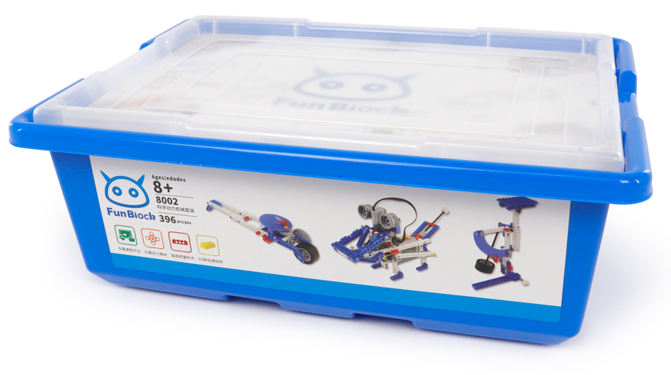
1. product information
model | 0801
material | Environmental protection ABS, etc.
packaged form | carton
package size | 44cm*32.5cm*17.5cm
weight | 2.5kg
number of parts | 396pcs
applicable age | 6+
Number of courses | 24+

2. Supporting Information
①Online platform teaching,②Electronic building atlas.
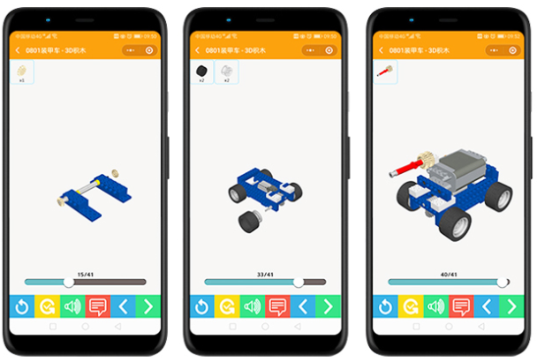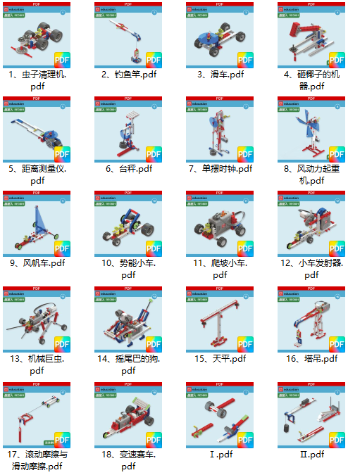

3. Presentation of modeling
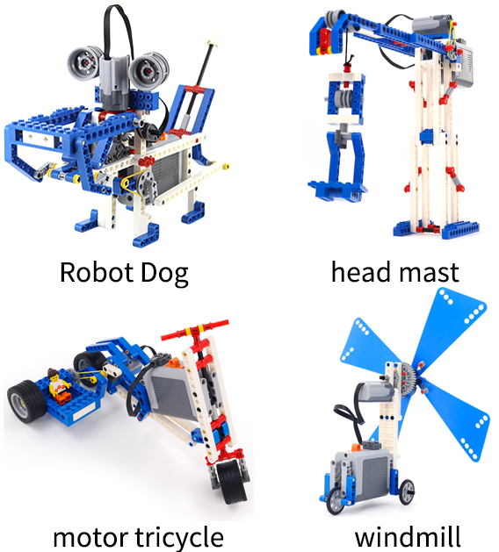
4. Group of electronics

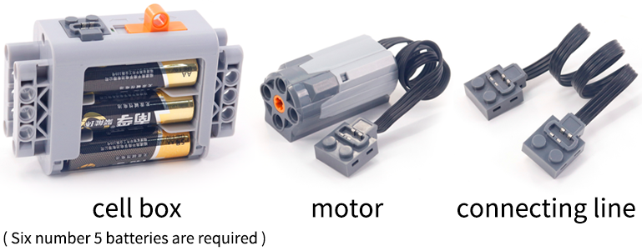

5. product list
