Animals and Flowers
Animal series have always been a favorite among babies, and this educational zoo theme is perfect for babies to learn about animals. It contains 24 animal models and rich animal habitat backgrounds such as forest, jungle, grassland, Arctic Ocean and river. The difference from the original version 9218 is that one lioness, two dolphins and two black bears are added instead of two brown bears.

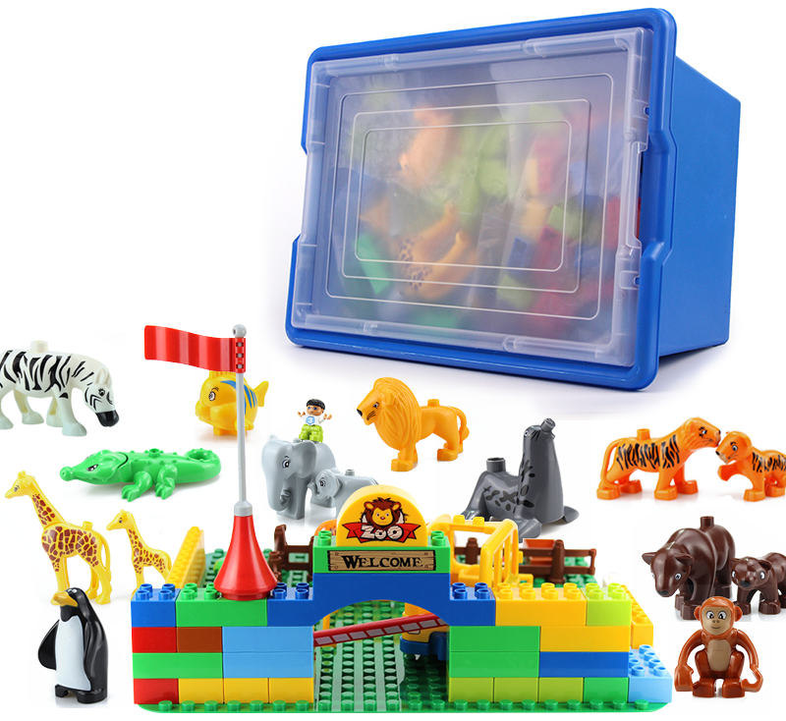

1. product information
model | 0607
material | Environmental protection ABS, etc.
packaged form | carton
package size | 44cm*32.5cm*17.5cm
weight | 3 kg
number of parts | 102 pcs
Number of courses | 3 +

2. Product display
3. Presentation of modeling
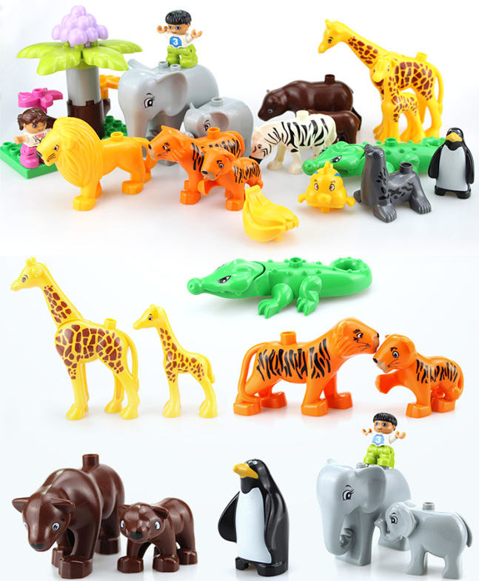

4. product list
