Artificial intelligence cottage kit
(Science Festival, school project, makerspace)
The kit consists of 25 basswood structures, 24 electronic blocks and several electronic accessories, and allows children to learn programming immersion by creating an AI villa, with 32 lessons of varying difficulty, enough to cover a year's school curriculum. We want students to learn and love programming while exercising their hands-on skills.

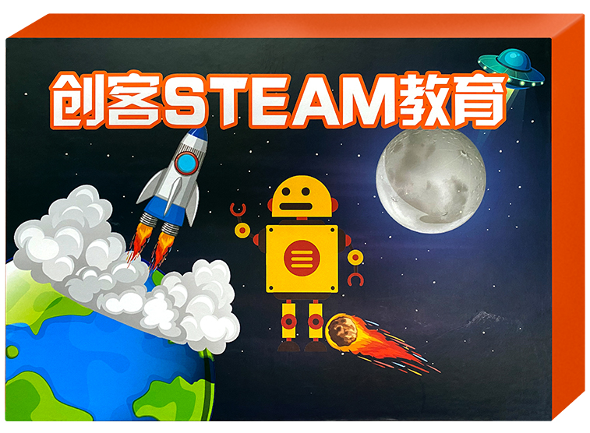
1. product information
model | quiet
packaged form | carton
package size | 36cm*25.5cm*8cm
weight | 1.5 kg
applicable age | 8 +
Number of courses | 33+

2. Product display
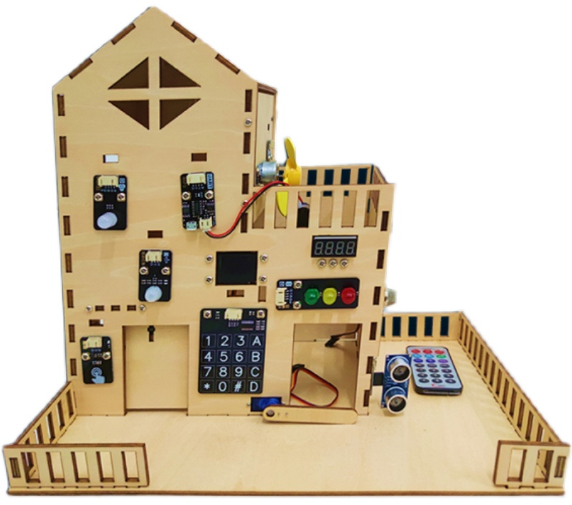
- Supporting Information
Electronic building atlas
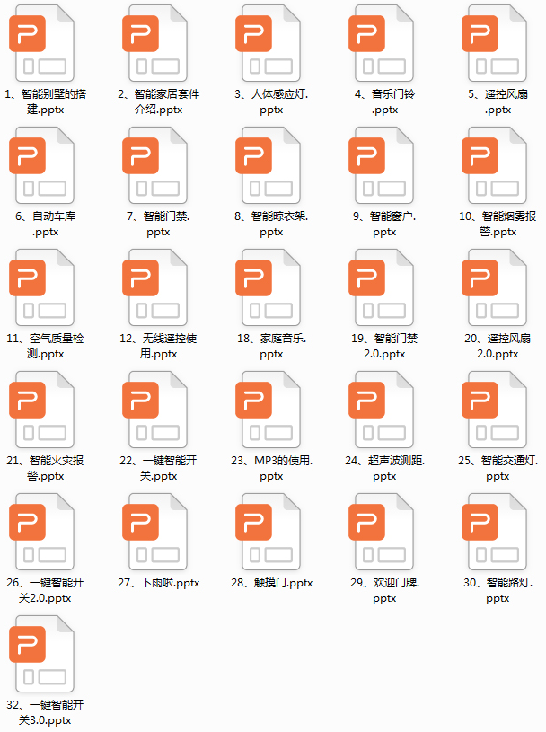
4. programming
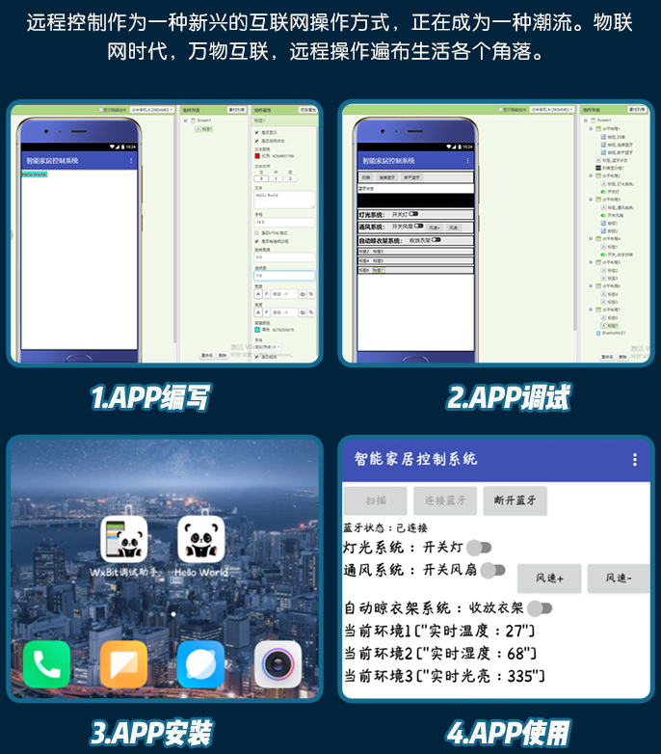
5. product list
