EV3
This set contains a basic construction manual. There are no less than 8 colors of each part in the robot set, and no less than 640 parts. It includes 2 large motors with built-in Angle sensors, 1 medium motor with built-in Angle sensors, 1 ultrasonic sensor, 1 color sensor, 2 touch sensors, 1 gyroscope sensor, 1 rechargeable battery, 1 charger, and roller, and 1 control core: Micro computer needs to be equipped with ARM 9 processor, LINUX system, 16MB flash memory, 64MBRAM, mini SD-32G memory, high-speed USB transmission, USB main device, Bluetooth, wireless support, 4 exits -4 entrances, come with speaker, 3 colors 6 buttons

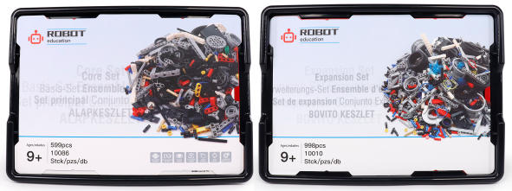

1. product information
model | 45544/45560
material | Environmental protection ABS, etc.
packaged form | carton
package size | 44cm*32.5cm*17.5cm
weight | 6kg
number of parts | 541 pcs + 853 pcs
applicable age | 9 +
Number of courses | 96节

2. Product display
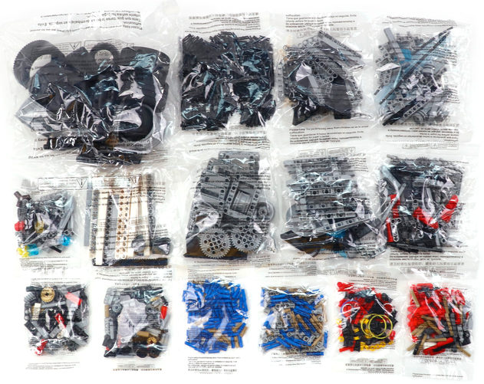
3. Supporting Information
①Online platform teaching,②Electronic building atlas.
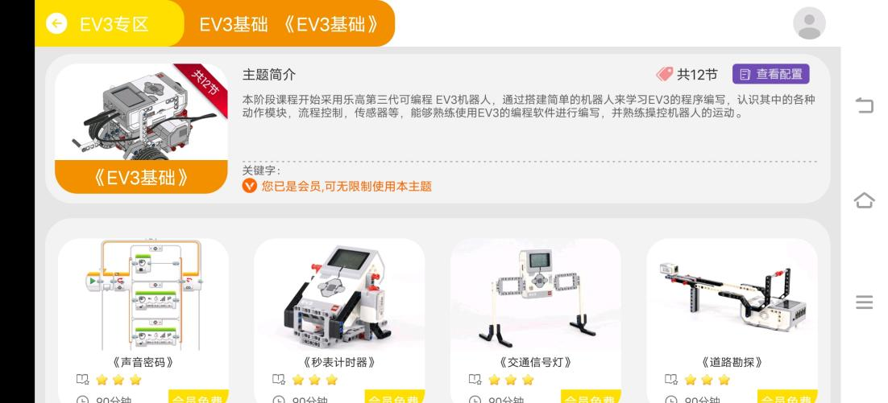
4. Presentation of modeling
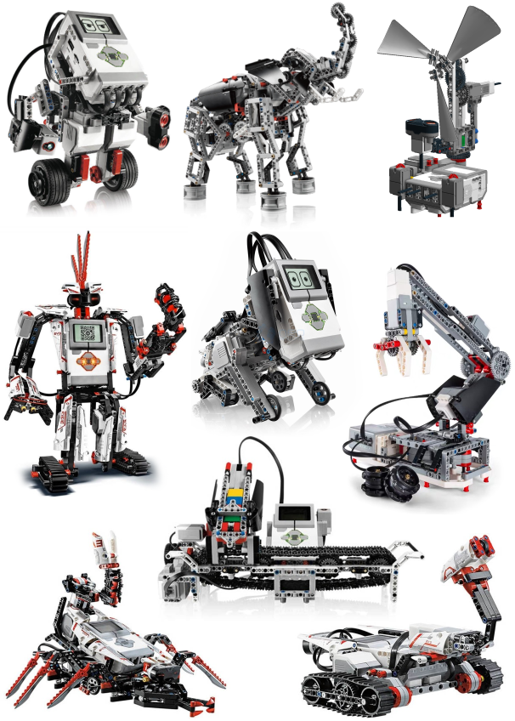

5. Electronic components
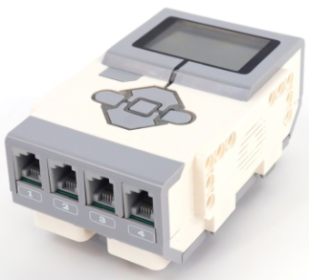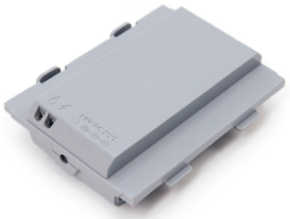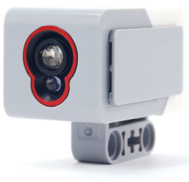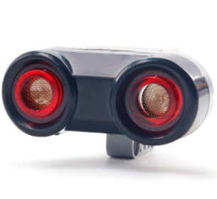
Intelligent Brick DC Rechargeable Battery Colour Sensor Ultrasonic Sensor
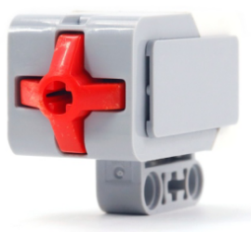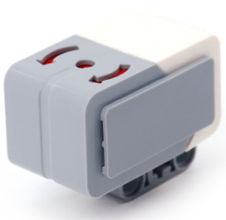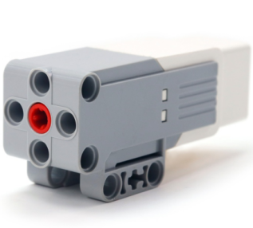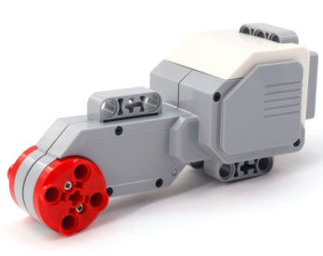
Touch Sensor Gyro Sensor Medium Servo Motor Large Servo Motor

6. product list
