Robot Grade examination Level 1 and 2
This set contains: 633 parts. Students can predict, observe, adjust and record various indicators through the model, and directly experience the knowledge of force, energy and magnetism.
It is equipped with the Learning manual of National Youth Robotics Grade Examination Candidates (Level 1).
Study Manual for Examinees of National Youth Robotics Rank Examination (Level 2)
National Youth Robotics Test candidates to build a manual, and provide students with 19 test questions reference cases, real question simulation.

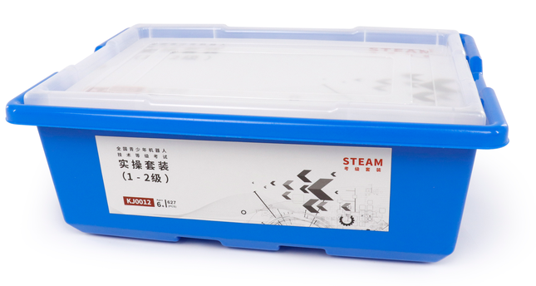

1. product information
model | 0803
material | Environmental protection ABS, etc.
packaged form | carton
package size | 44cm*32.5cm*17.5cm
weight | 2.5 kg
number of parts | 633 pcs
applicable age | 6 +
Number of courses | 24 +

2. Product display
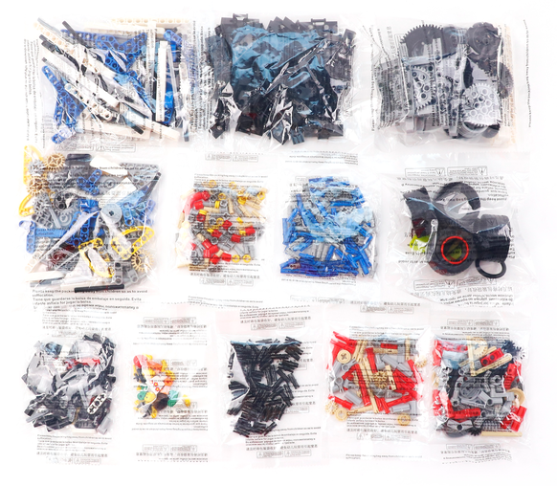
3. Supporting Information
①Online platform teaching,②Electronic building atlas.
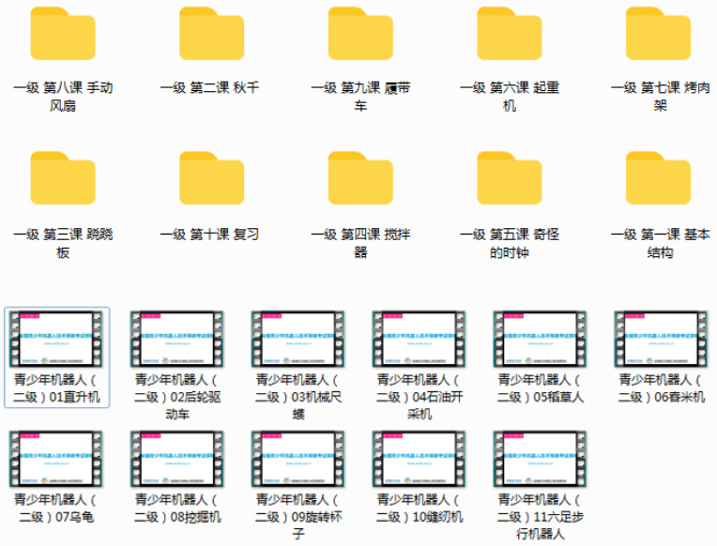
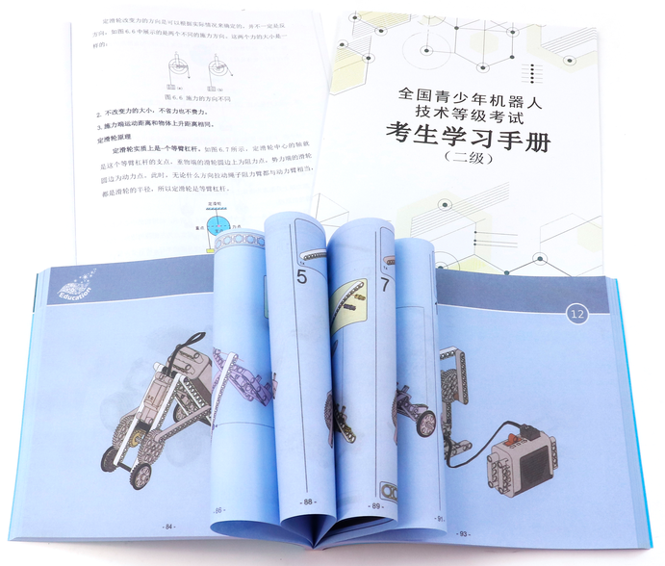
4. Presentation of modeling
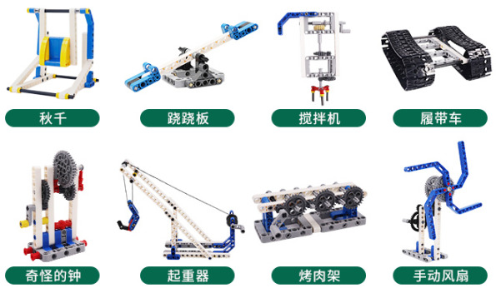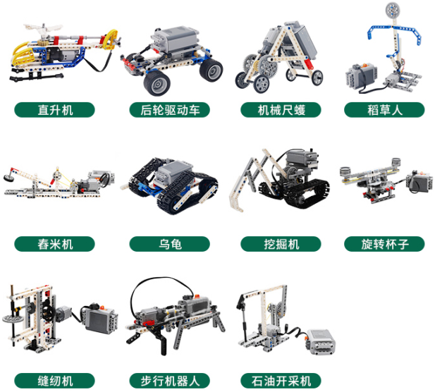
5. Group of electronics
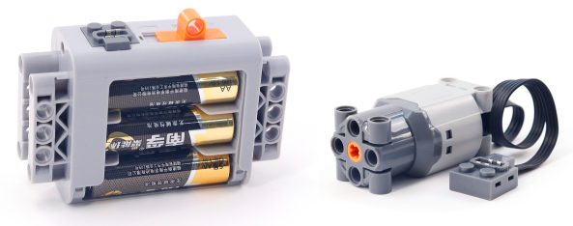
电池盒 马达

6. product list
