Robot level Examination 3 and 4

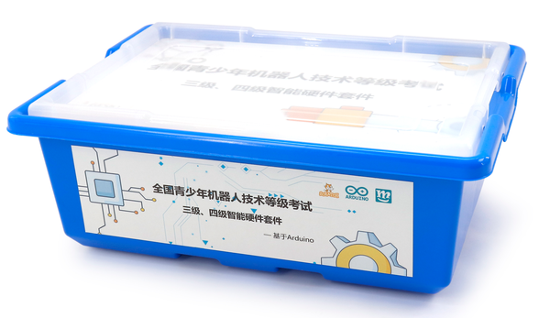
1. Product Information
model | ARDU-Uno-TA
material | Environmental protection ABS+ aluminum alloy + chip, etc
packaged form | carton
package size | 44cm*32.5cm*17.5cm
weight | 3 kg
applicable age | 8+
Number of courses | 24+

2. Product display
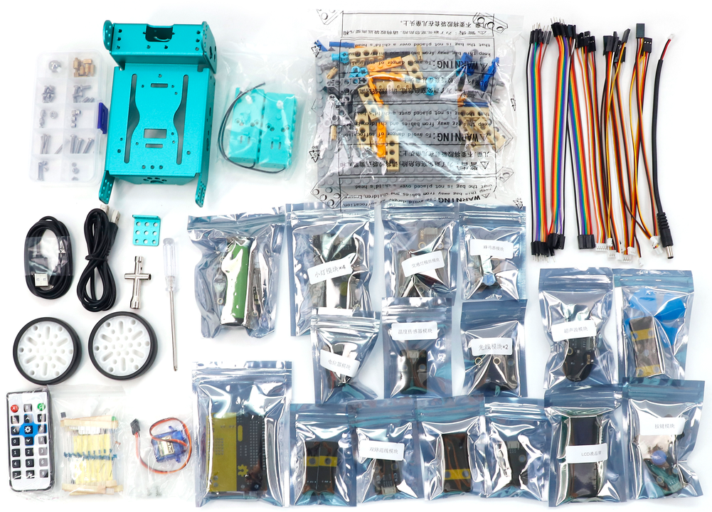

3. Supporting Information
①Online platform teaching,②Electronic building atlas.
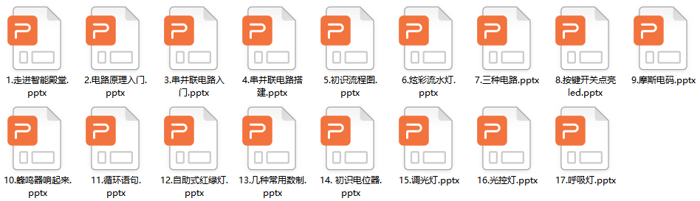
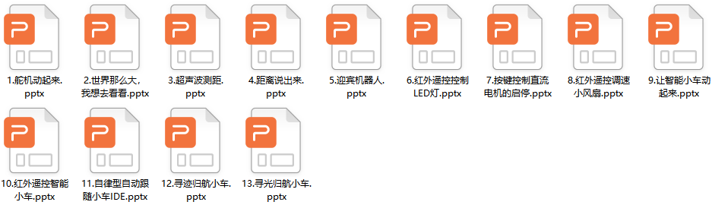
4. Presentation of modeling
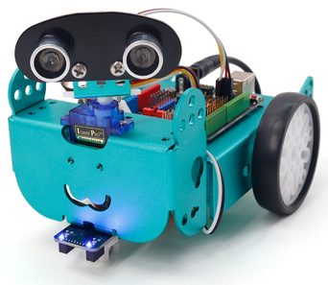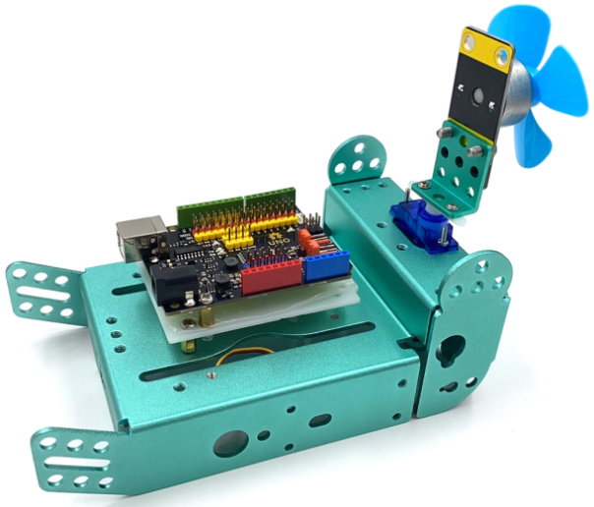
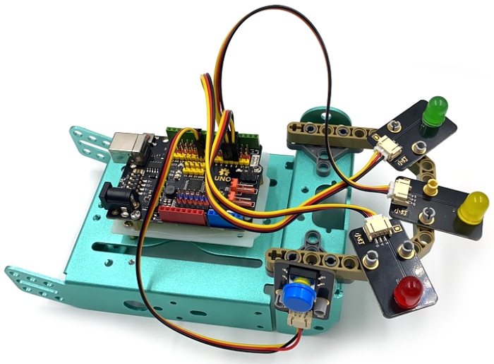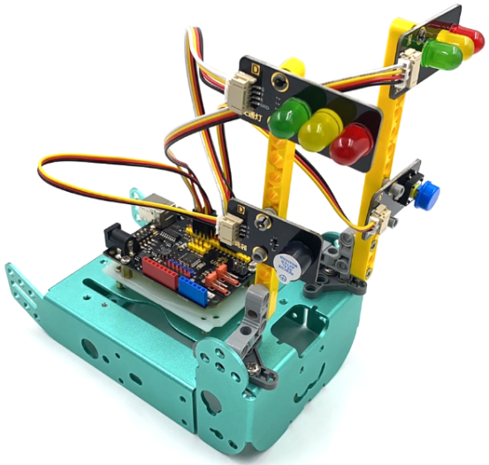
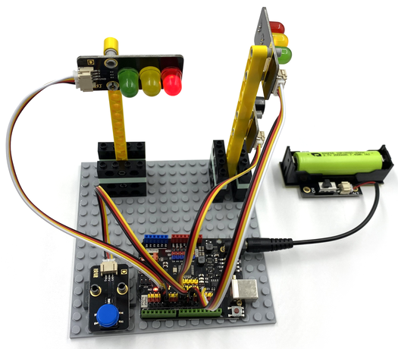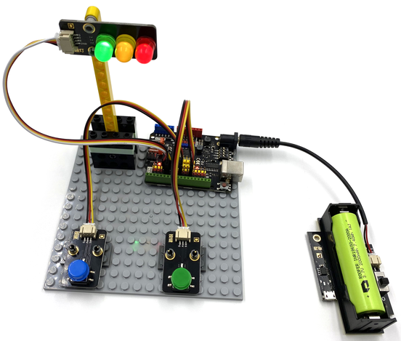

5. Group of electronics
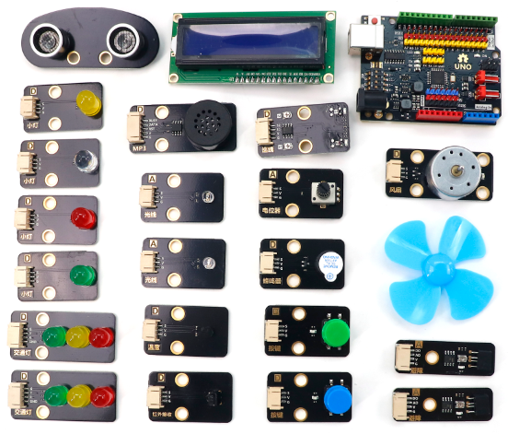
6. product list
