Robot grade test 5 and 6
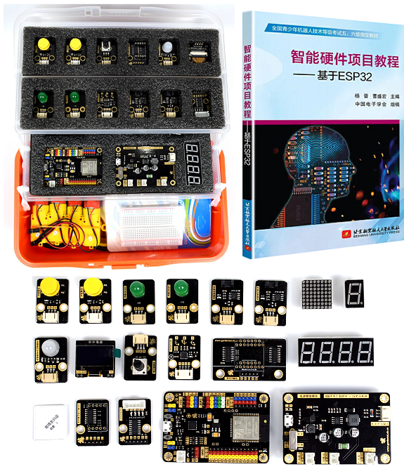

1. product information
model | ESP-Do-TA
material | Environmental protection ABS+ aluminum alloy + chip, etc
packaged form | carton
package size | 44cm*32.5cm*17.5cm
weight | 3 kg
applicable age | 9 +
Number of courses | 30 +

2. Product display
