Smart House toddler programming
(No computer programming required)

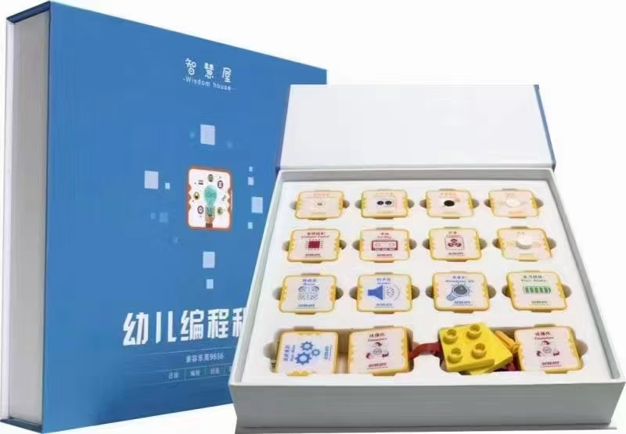

1. product information
model | 0605
material | Environmental protection ABS, etc.
packaged form | carton
package size | 28cm*28cm*8cm
weight | 1 kg
applicable age | 5 +
Number of courses | 48+

2. Product display
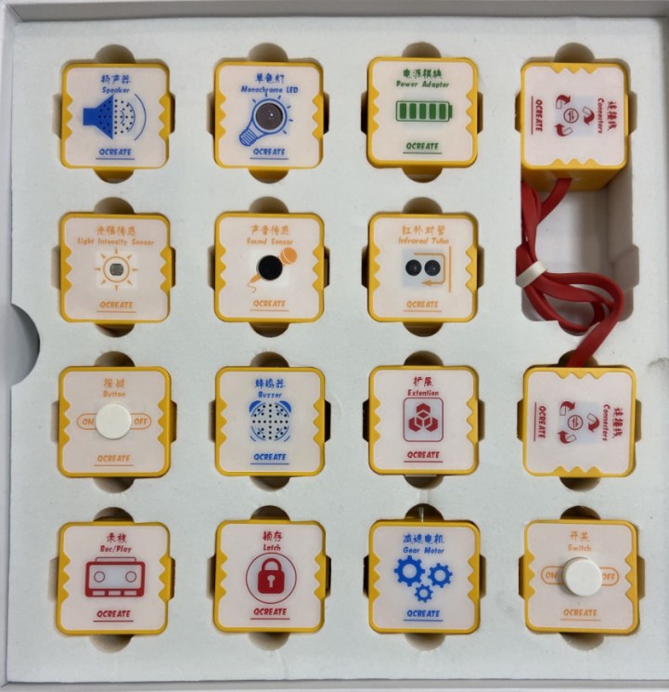

3. Supporting Information
①Online platform teaching,②Electronic building atlas.
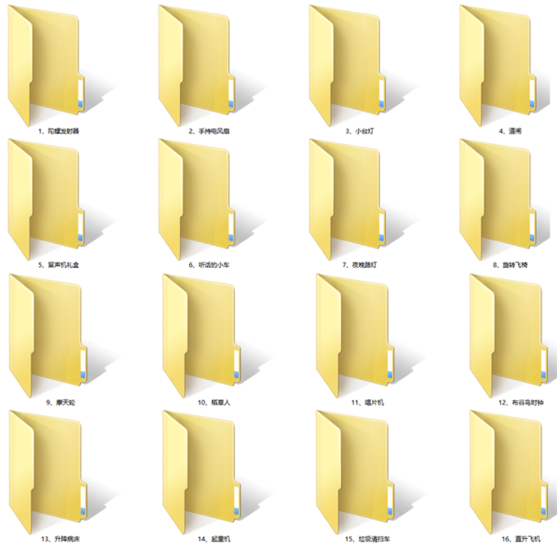
4. Presentation of modeling
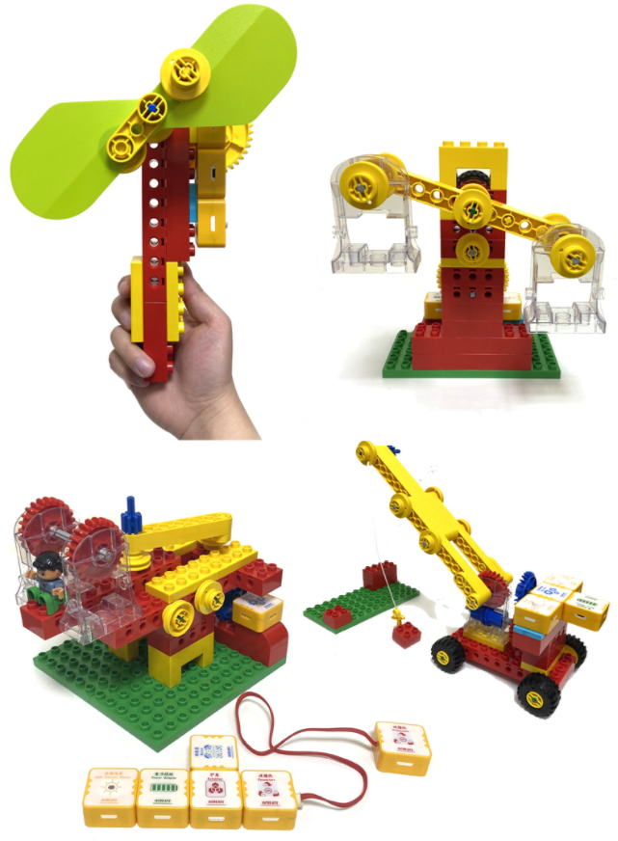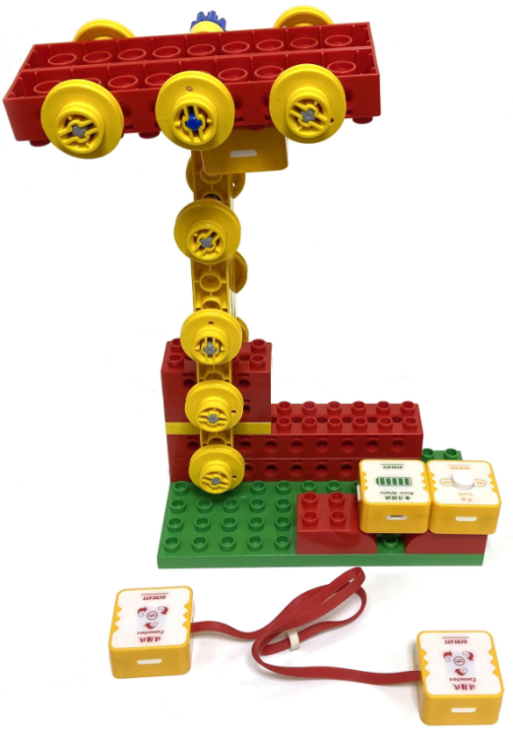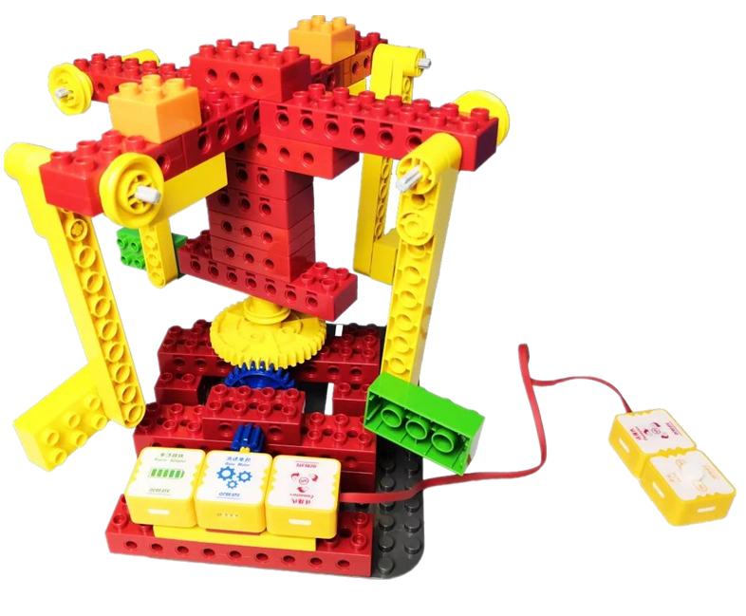

5. product list
