aduino series one small car

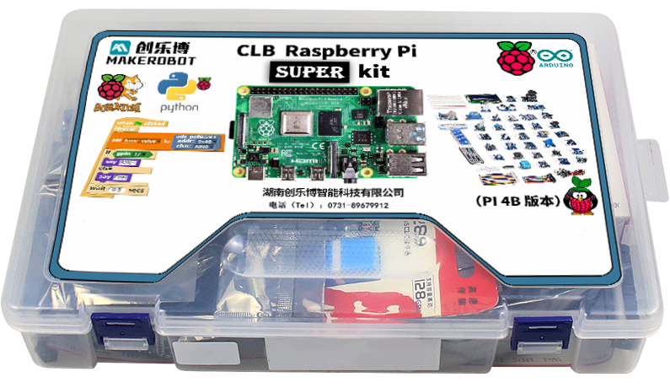

1. product information
model | one
material | Aluminum alloy + chip, etc
packaged form | carton
package size | 11cm*11cm*5cm
weight | 0.2 kg
applicable age | 8+
Number of courses | 16 +

2. Product display
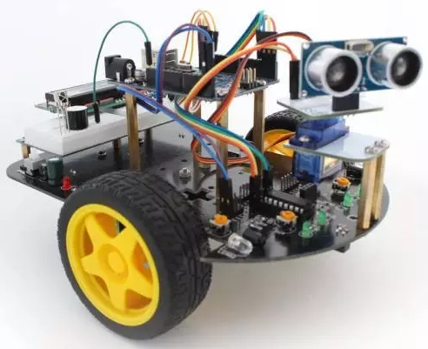

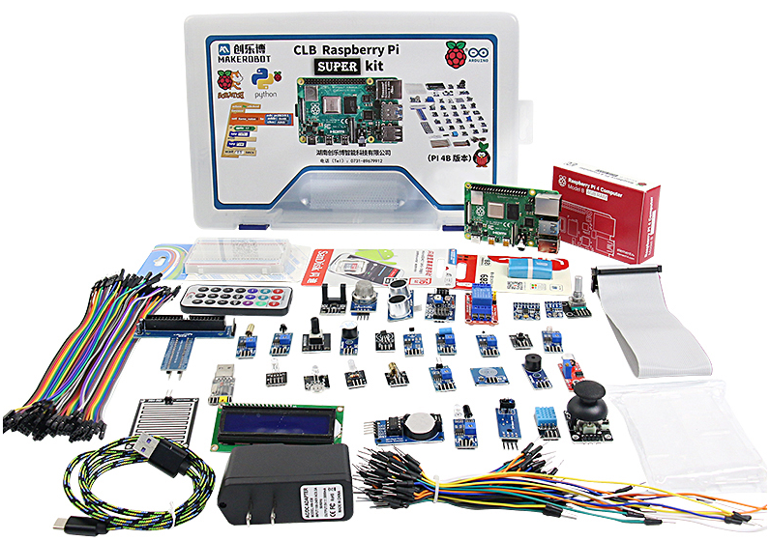

3. Supporting Information
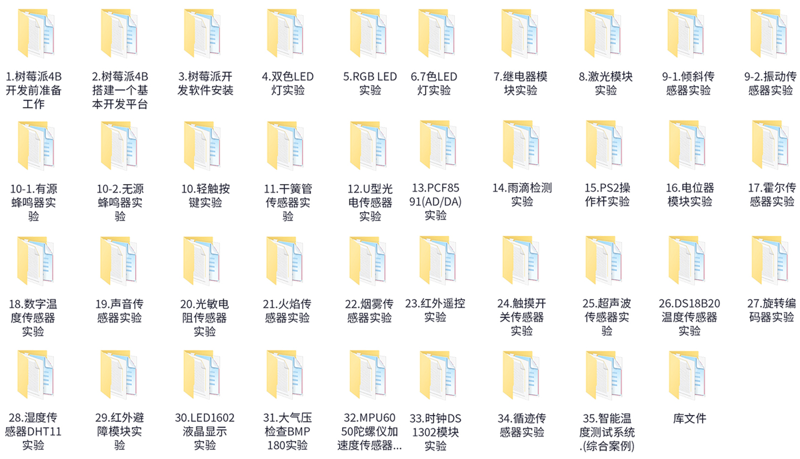
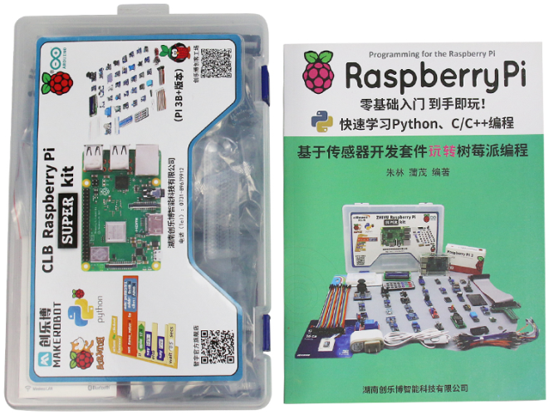

4. Electronic components
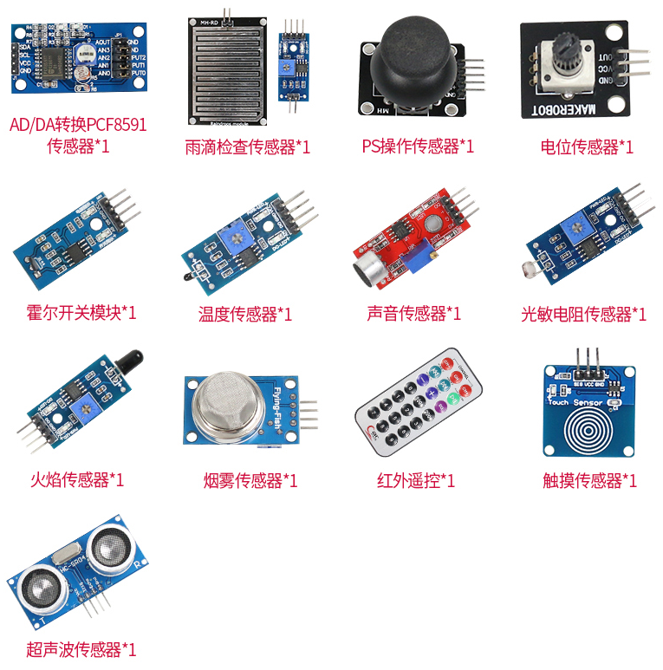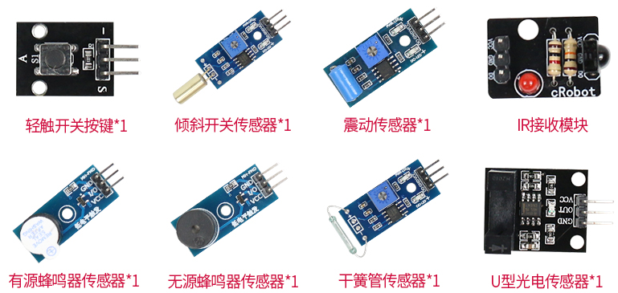

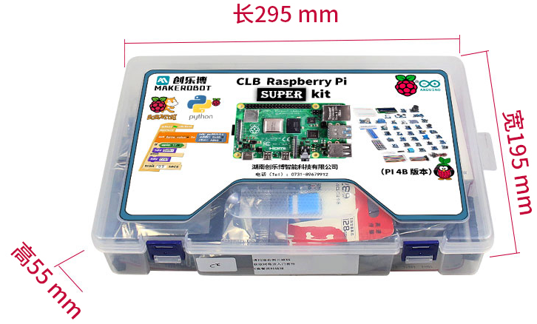

Hands-on project teaching video:
Provides 35 experimental project tutorials, so that you can easily learn the development and application of Raspberry PI and C/C++ programs, Python programs, Linux system development, sensor application development and other embedded application development projects.
