mircobit expansion series zero car
(bit board can be sold separately)

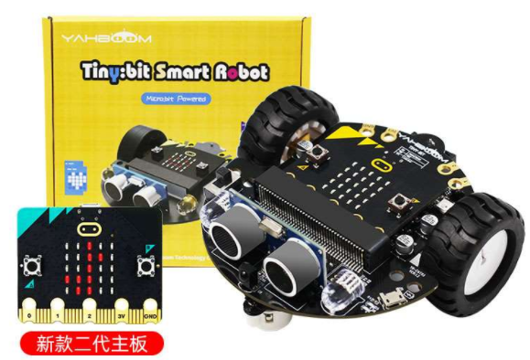

1. product information
model | Zero
material | Aluminum alloy + chip, etc
packaged form | carton
package size | 11cm*11cm*5cm
weight | 0.2kg
applicable age | 8 +
Number of courses | 48 +

2. Product display
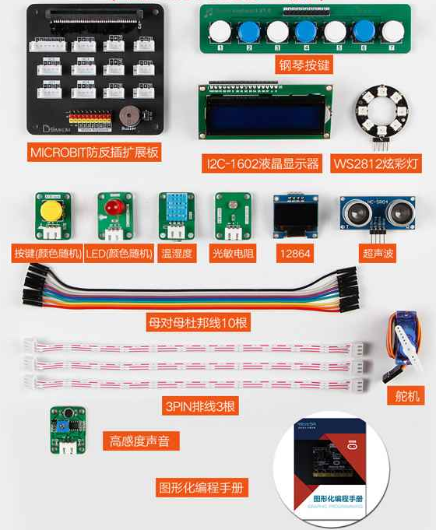
3. Presentation of modeling
