wedo
This set contains: 280 parts, block 8 colors, hole spacing 8mm, block height 3.2 millimeters multiple, contains block bricks, gears, shafts, tires, rubber bands.
Robot host: 1. Connected to electronic devices via Bluetooth low power, 2. Two sensor or motor interfaces, 3. One light, 4. One switch, 5. Use two 5 batteries or matching rechargeable batteries, 6. Blinking. White: Waiting to connect to Bluetooth. Blue: The Bluetooth connection is complete. Blinking. Orange: The power supply to the motor reaches the limit.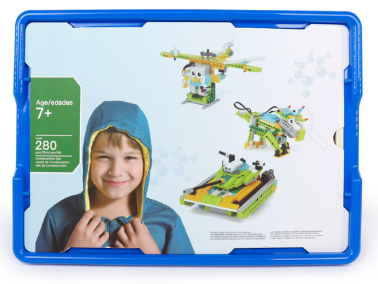

1. product information
model | 0806
material | Environmental protection ABS, etc.
packaged form | carton
package size | 44cm*32.5cm*10cm
weight | 2 kg
number of parts | 280 pcs
applicable age | 7 +
Number of courses | 48 +

2. Product display
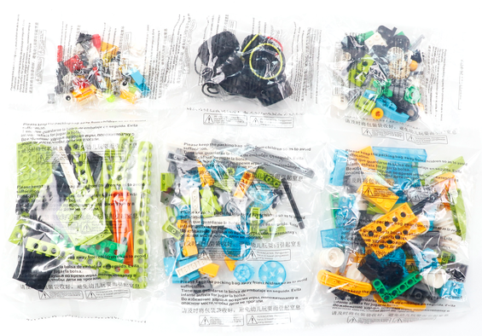

3. Supporting Information
①Online platform teaching,②Electronic building atlas.
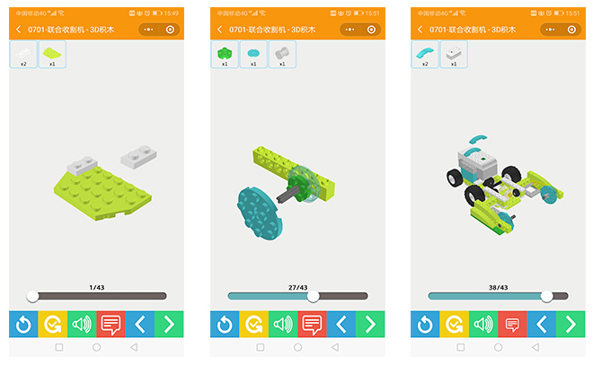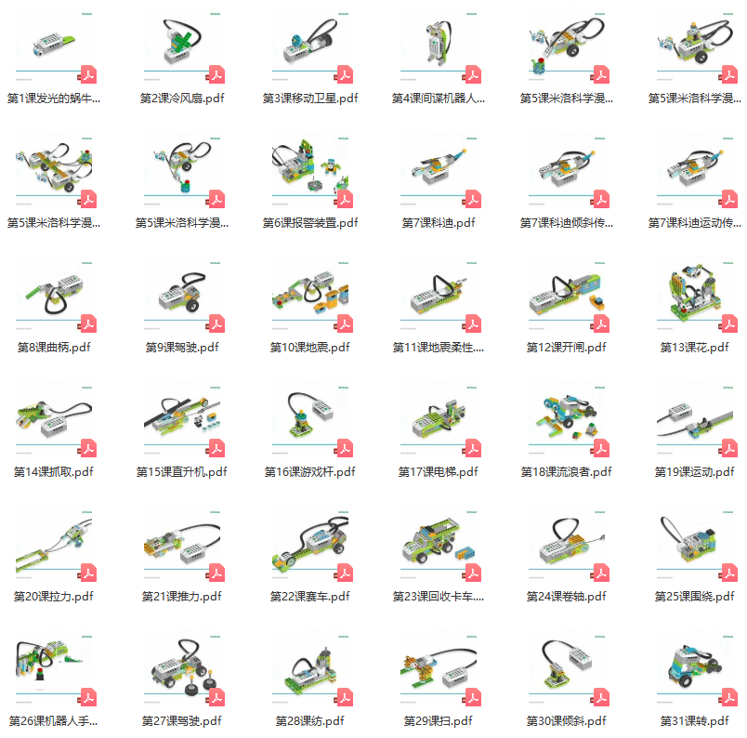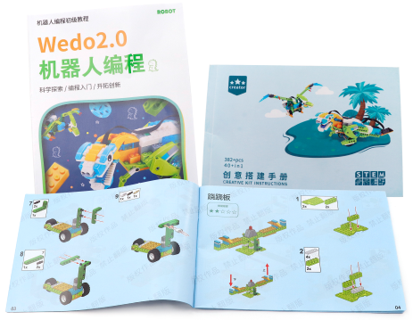

4. Presentation of modeling
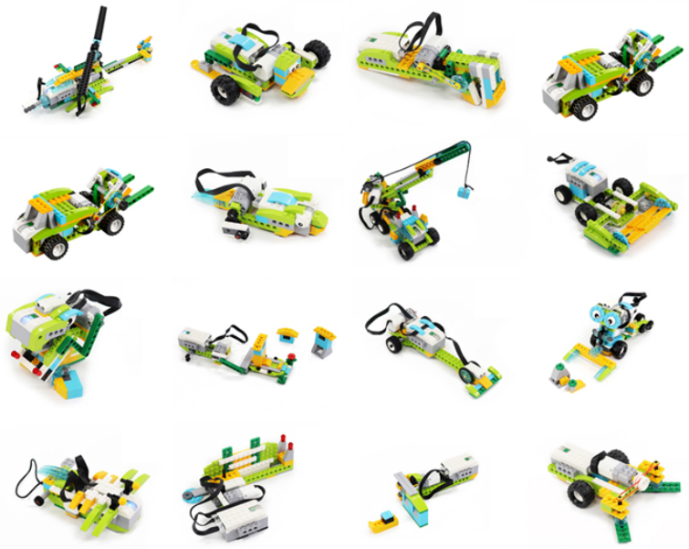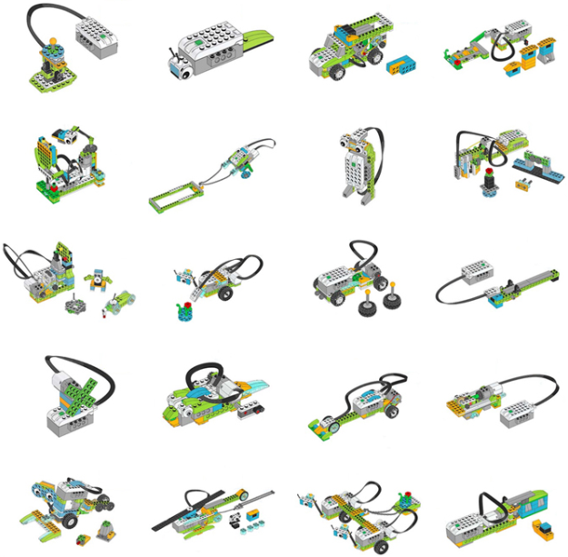

5. Group of electronics
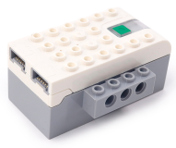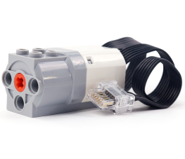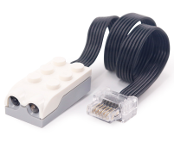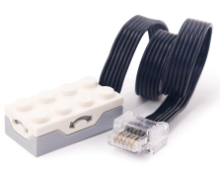
Cell box Motor Range sensor Inclination sensor

6. product list
